1. Design TM using simulator to accept the input string ww

INPUT:

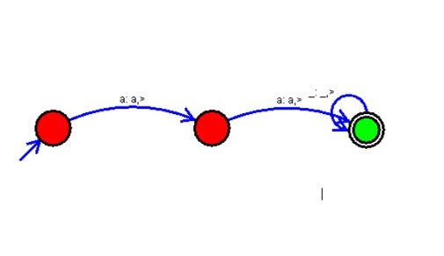

OUTPUT:

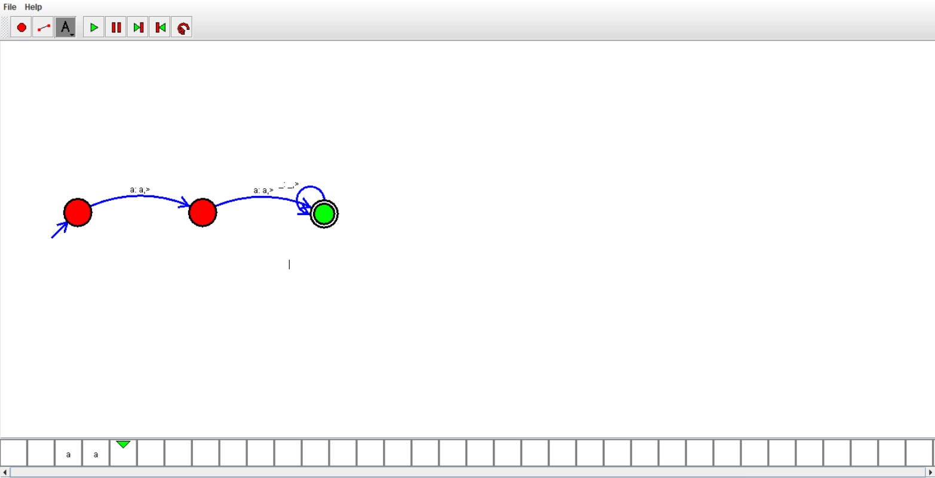

RESULTS:

We designedTM using to accept the input string ww by using autosim